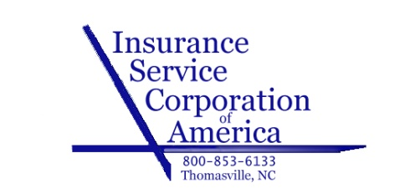

Request for Certificate of Insurance

PLEASE EMAIL ALL REQUESTS FOR CERTIFICATES TO Janet@iscofa.com

**** This is to ensure that all certificates of insurance are processed correctly.
Please call 1-800-853-6133 if you have any questions.

Your Company Name _____________________________________________________________

Please provide Contact name and Phone number in case we have any questions.

Which of the following type(s) of coverage is the certificate request for:
_____Professional Liability ______General Liability ______Workers Comp.

_____Auto ______Umbrella ______other_____________________

Name of Certificate Holder _______________________________________________________________

Attention to: ___________________________________________________________________________

Mailing Address ________________________________________________________________________

City/State/Zip __________________________________________________________________________

Holder’s email address: ______________________________________________________
OR
Fax number: ___________________________________________________________________________

Do you want certificate mailed to Certificate Holder also? _____Yes ______No

Other Instructions:

Please attach any additional requirements
P O BOX 2399
Thomasville, NC 27361-2399
Phone: 800-853-6133 Fax: 866-833-6910

